Come and Join the 409 Group for a Covered Dish
Thanksgiving Dinner

As We Give Thanks to the Narcotics Anonymous Fellowship

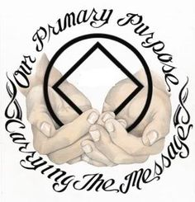
Bring a dish
to share

Come
and
fellowship

5:00 PM on Thanksgiving Day at Christ the King Lutheran Church
623 S. Thornton Ave., Dalton GA 30720

Volunteers are needed to set-up and/or clean-up.
If you can help, call 706-280-2296 or 706-980-0125

